Laura Kampschroeder
13407 W. 80th Terr.
Lenexa KS 66215



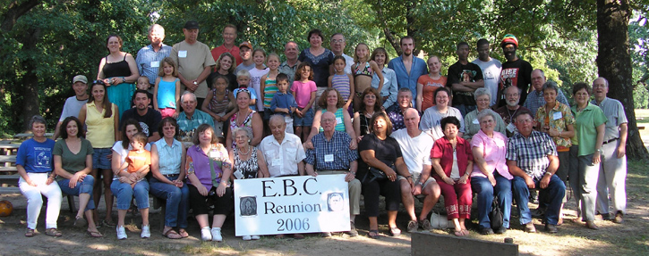
EBC Reunion 2009
We had fun
in Kansas
in 2006→

Let’s do it

again this summer!

Please

join us at

Tall Oaks

in Kansas

Friday, July 3 to Sunday, July 5, 2009

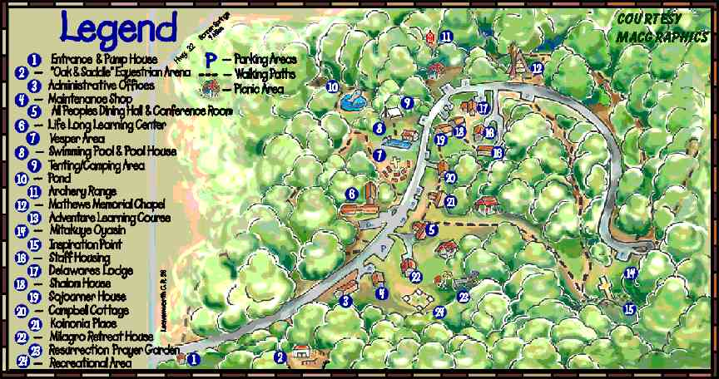
The 350 beautiful wooded acres
of Tall Oaks is halfway between the western edge of Kansas City
& the NE corner of Lawrence…
2 miles east of Linwood, Kansas
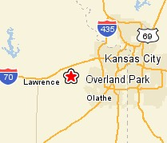
11th Triennial
V2a

Tall Oaks www.talloaks.org
Located on 350 beautiful woodland acres, Tall Oaks is only fifteen miles from both the western edge of Kansas City & the northeast corner of Lawrence, Kansas (two miles east
of Linwood, Kansas 66052). We selected this site for its relaxed setting & activities for kids.

Meals: All meals will be prepared for us (hooray!). Those on special diets may need
to bring their own food, although most (diabetic, vegetarians, etc) like the dining hall food.

Activities: Outdoor Swimming Pool • Horseback Riding • 5 miles of hiking and
horse trails • High, low and portable challenge • Unique outdoor chapels • Picnic area
with all traditional games • Nature program • Archery • Hayrides
Restrictions: No pets, alcohol, illegal drugs, firearms, fireworks or indoor smoking.

Rooms: The main building, LLC (Lifelong Learning Center), holds up to 48 people
in 12 motel-style rooms. Each room has 2 twin beds, a bunk bed, and a private bath,
and is designed to hold up to 4 persons. If some prefer 2 per room, we may also need
the Milagro cottage, which holds up to 16 persons in 4 similar-style rooms.

Rates: The price of the registration includes 2 overnights (Fri and Sat) plus 5 meals
(3 on Sat and 2 on Sun). Rates are charged by the number in each room. For example,
if 2 adults + 1 youth share a room, each would pay the triple rate according to their age.
Adult (18-up) Youth (5-17) Kids under 5
2 per room (each person) $142 $108 free
3 per room (each person) $120 $86 free
4 per room (each person) $116 $82 free

Registration for EBC 2009 Reunion at Tall Oaks near Linwood, Kansas 66052 • www.talloaks.org
Friday, July 3 to Sunday, July 5

Name & Address:
Names of persons planning to attend: Age Room with 2, 3, or 4 Any special needs?
1.
2.
3.
Write additional names on a separate sheet of paper.

Swimming, hiking and picnic area with traditional games are free, but need to be reserved 30 days in advance. Please indicate if anyone in your family is interested in the following free activities (mark all that apply).
___ Swimming ___ Hiking ___ Games: __ horseshoes __ softball __ sand volleyball __ croquet
__ basketball __ soccer __ other________________________
Please indicate how many are interested in the following paid activities. Amounts are per person; minimum numbers are required.
___$14 Horseback trail ride ___$7 Horseback lead line ___$4 Wagon ride & s’mores
12 yrs & up (min. 8) 5-11 yrs All ages (min. 10)

Return form by Friday, May 8 to: Gwen Eidman • 2650 215th Rd. • Emporia, KS 66801
Return form below to Gwen Eidman by Friday, May 8, 2009:
Please help us count! Let us know how many plan to come and your preferences. Detach and return the Registration Form by May 8. Tall Oaks is a popular summer retreat, so we must know the size of our group and pay by May 14, 2009. Make your checks payable to EBC Reunion (EBC treasurer will make group payment to Tall Oaks).

[Detach and send] - - - - - - - - - - - - - - - - - - - - - - - - - - - - - - - - - - - - - - - - - - - - - - - - - - - - - - - - -
For updates & information, visit either of our websites
www.EBCReunion.org (points to both web pages below)
www.geocities.com/Heartland/Arbor/1591/default.htm (by Laura)
www.EBC.tzo.com/2009 (by Kriss)

or call or email the Reunion Committee
Gwen Eidman, Treas. 620-343-1473 geidman@hotmail.com
Laura Kampshroeder 913-888-6606 kamps@everestkc.net
Earl Visser 402-730-1075 earl_visser@yahoo.com
Jonne Long 816-741-9293 JLong14@kc.rr.com
Lauraine Mulally 785-843-1836
Cheri Black 215-882-4351 cblack7020@gmail.com
Kriss Avery 314-298-0297 kriss@rainbowsound.us
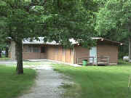
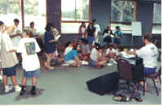

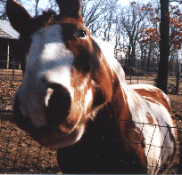
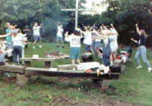
If you have questions about Tall Oaks, contact any member of the Reunion Committee, or the Tall Oaks Director, Sharon at sharon@talloaks.org or 800-617-1484.
Our Treasurer, Gwen Eidman, will coordinate the EBC REUNION GROUP reservation.

